Client Dashboard FAQ
Below are frequently asked questions about the Client Dashboard

How do I sign in for the first time?
You will receive an activation email from CliftonLarsonAllen Wealth Advisors, LLC with a hyperlink to the sign in page and your email and temporary password you will use to log in for the first time.
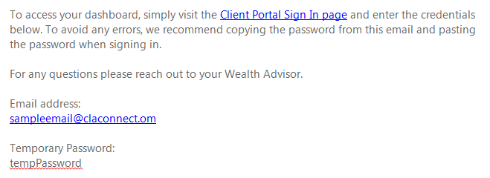
After clicking on the link to the sign in page and typing in your email and temporary password you will be prompted to accept the terms and conditions of using the Client Dashboard. After hitting accept you will be directed the landing page of the Client Dashboard.

What is the URL for the log in page?
The address for the log in page is: claconnect.portal.tamaracinc.com

Who do I contact with questions or issues?
Your advisor(s) or individuals you work with will be able to assist with any questions or issues you are having.

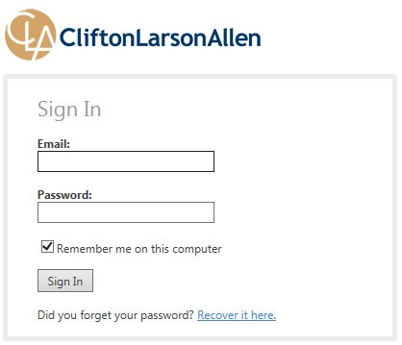
How do I reset my password?
Step 1: By selecting the “Recover it here” link at the bottom the user will be able to reset their password. Upon clicking the link the user will be prompted to enter in their email address.

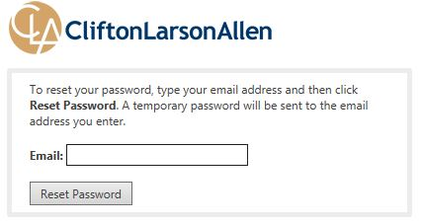
Step 2: This will be the same email address they use to log in.

Step 3: The user will receive an email with a temporary password. The user will then go back to the log in page (claconnect.portal.tamaracinc.com) and enter their email and temporary password.
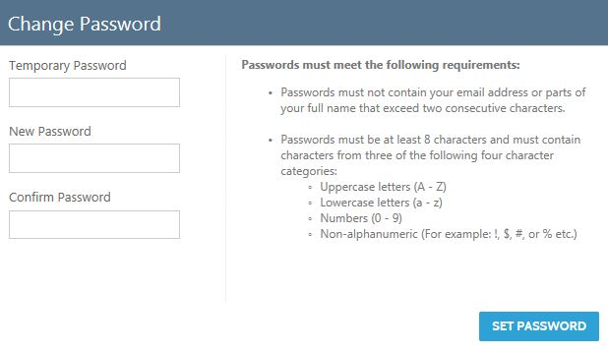
Step 4: Once the user has entered in their email and temporary password they will be prompted to create a new password. The password must meet the following criteria:
- Passwords must not contain your email address or parts of your full name that exceed two consecutive characters.
- Passwords must be at least 8 characters and must contain characters from three of the following four character categories:
  - Uppercase letters (A - Z)
  - Lowercase letters (a - z)
  - Numbers (0 - 9)
  - Non-alphanumeric (For example: !, $, #, or % etc.)

How to Navigate in the Client Dashboard?
Navigation for the Client Dashboard is broken down into five areas; Main Page (Home), Accounts, Reports, Documents and Service Team.
The home button will always bring the user back to the screen they see when they log in. Each section will be highlighted as the user moves their mouse over the top of them. From any one of the sections the user can click and see another section.

How to upload a document?
When you are ready to post a document you will navigate to the Documents section of the Client Dashboard (Click on Documents in the top navigation bar). In the documents section you will see a button; Post Documents.
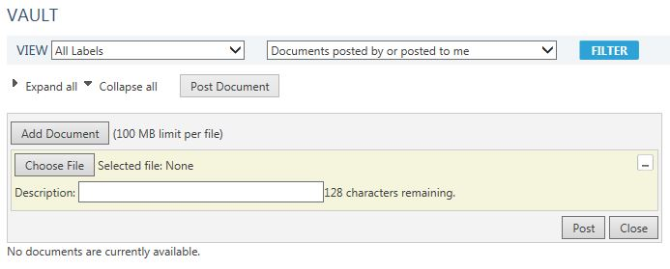
You are able to upload more than one document at a time but there is a 100 MB limit per file. Once you have selected the files/documents you wish to upload the user will select Post. Your service team will receive an email letting them know that a document has been posted.

What information is available?
You are able to view many of the metrics that you are familiar with on the quarterly report.

Main Page (Dashboard) Tiles
- Managed Market Value: The value is the previous business days ending value
- Investment Gain: Investment gain can be broken out by Year to Date, Previous 3 Years and Inception to date. The data is calculated using annualized returns.
- Net Contribution: Net contribution can be viewed either by Year to Date or Previous 12 months. The data is calculated using annualized returns and includes intra-group flows.
- Contribution Rate: Contribution rate can be viewed either by Year to Date or Previous 12 months. The data is calculated using annualized returns and includes intra-group flows.

Main Page (Dashboard) & Reports
- Asset Allocation: The asset allocation is based on our current asset categories.
- 2016 & 2017 YTD Account Summary: The 2017 YTD Account Summary and the 2016 YTD Account Summary (available on the reports section) both use the same logic to determine the values. The data includes capital gains in the realized gain/loss columns and includes intra-group flows.
- Performance by Asset Class: The Performance by Asset Class chart summarizes the data based on year to date and inception to date while providing both a percentage and a dollar amount.
- Capital Flows: The Capital Flows chart groups the data by year and shows the values based on inception to date. The report is based on managed assets only.
- Current Holdings: The current holdings report is grouped by asset class and of the last market close. The symbol hyperlinks are to yahoo finance but not all symbols are available through yahoo finance.
- Market Charts: The market charts allow the client to view in real time information about the stock markets. The information is provided by IDC.

Accounts:
The Accounts tab allows the client to view all of their financial accounts and any groups that have been included. They can view the Account Name, Account Number, Account Type, Current Value, Inception Date, Objective and Year to Date Net Return.

